Agenda Item : 2/04

= application site



Flats 330 to 332B Alexandra Avenue, Harrow | P/5563/16

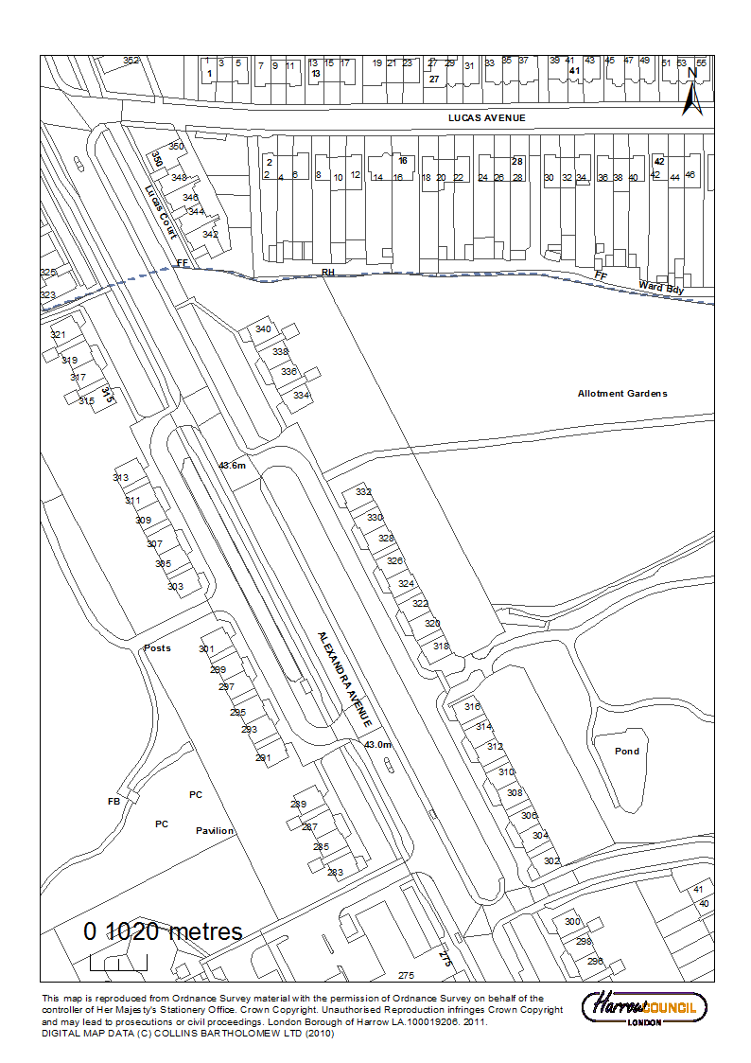

Flats 330 to 332B Alexandra Avenue, Harrow | P/5563/16

LONDON BOROUGH OF HARROW

PLANNING COMMITTEE

30th May 2018

Application Number: | P/5563/16
Validate Date: | 17/01/2017
Location: | 330 to 332B Alexandra Avenue, Harrow
Ward: | Roxbourne
Postcode: | HA2 9DX
Applicant: | Harrow Council
Agent: | LBA
Case Officer: | Catriona Cooke
Expiry Date: | 01/03/2017
PURPOSE OF REPORT/PROPOSAL

The purpose of this report is to set out the Officer recommendations to the Planning Committee regarding an application for planning permission relating to the following proposal.

Construction of a three storey block of six flats attached to the existing building

The Planning Committee is asked to:

RECOMMENDATION A

- agree the reasons for approval as set out in this report, and

- grant planning permission subject to the conditions listed in Appendix 1 of this report.

REASON FOR RECOMMENDATION

The proposed development would make a more efficient use of this previously developed site and would make a welcome contribution to the supply of new housing to the Council Housing Stock. It would accord with the Borough’s spatial vision and strategy as set out in the Harrow Core Strategy. The development of the site is therefore considered to be acceptable in principle.

INFORMATION

The application is reported to the Planning Committee as the subject site is owned by the Council and is over 100sqm in area and the proposal relates to the construction of 6 dwellings. As such, it falls outside the scope of the exception criteria set out at Part 1(h) of the Scheme of Delegation dated 29th May 2013.
Statutory Return Type: |  | E13 Minor Dwellings
Council Interest: |  | The land is owned by the Council
GLA Community Infrastructure Levy (CIL) Contribution (provisional): |  | £16,065
Local CIL requirement: |  | £50,490
HUMAN RIGHTS ACT

The provisions of the Human Rights Act 1998 have been taken into account in the processing of the application and the preparation of this report.

EQUALITIES

In determining this planning application the Council has regard to its equalities obligations including its obligations under section 149 of the Equality Act 2010.

For the purposes of this application there are no adverse equalities issues.

S17 Crime & Disorder Act

Policies 7.3.B and 7.13.B of The London Plan and Policy DM1 of the Development Management Polices Local Plan require all new developments to have regard to safety and the measures to reduce crime in the design of development proposal. It is considered that the development does not adversely affect crime risk.

LOCAL GOVERNMENT (ACCESS TO INFORMATION) ACT 1985
BACKGROUND PAPERS USED IN PREPARING THIS REPORT:

- Planning Application
- Statutory Register of Planning Decisions
- Correspondence with Adjoining Occupiers
- Correspondence with Statutory Bodies
- Correspondence with other Council Departments
- National Planning Policy Framework
- London Plan
- Local Plan - Core Strategy, Development Management Policies, SPGs
- Other relevant guidance

LIST OF ENCLOSURES / APPENDICES:

Officer Report:
Part 1: Planning Application Fact Sheet
Part 2: Officer Assessment
Appendix 1 – Conditions and Informatives
Appendix 2 – Site Plan
Appendix 3 – Site Photographs
Appendix 4 – Plans and Elevations

OFFICER REPORT

PART 1: Planning Application Fact Sheet

The Site

Address | 330 to 332B Alexandra Avenue, Harrow
Applicant | Harrow Council
Ward | Roxbourne
Local Plan allocation | No
Conservation Area | No
Listed Building | No
Setting of Listed Building | No
Building of Local Interest | No
Tree Preservation Order | No
Other

Housing

Density | Proposed Density hr/ha | 449
Density | Proposed Density u/ph | 168
Density | PTAL | 3
Density | London Plan Density Range | 70-170 u/HA
Dwelling Mix | Studio (no. / %)
Dwelling Mix | 1 bed ( no. / %) | 1/17%
Dwelling Mix | 2 bed ( no. / %) | 5/83%
Dwelling Mix | 3 bed ( no. / %)
Dwelling Mix | 4 bed ( no. / %)
Dwelling Mix | Overall % of Affordable Housing | 100%
Dwelling Mix | Social Rent (no. / %)
Dwelling Mix | Intermediate (no. / %)
Dwelling Mix | Private (no. / %)
Dwelling Mix | Commuted Sum
Dwelling Mix | Comply with London Housing SPG? | Yes
Dwelling Mix | Comply with London Housing SPG? | Yes
Dwelling Mix | Comply with M4(2) of Building Regulations? | Yes

Transportation

Car parking | No. Existing Car Parking spaces | 50
Car parking | No. Proposed Car Parking spaces | 58
Car parking | Proposed Parking Ratio | 1:1.1
Cycle Parking | No. Existing Cycle Parking spaces | 0
Cycle Parking | No. Proposed Cycle Parking spaces | 12
Cycle Parking | Cycle Parking Ratio | 1:2
Public Transport | PTAL Rating | 3
Public Transport | Closest Rail Station / Distance (m) | 740m
Public Transport | Bus Routes
Parking Controls | Controlled Parking Zone? | No
Parking Controls | CPZ Hours
Parking Controls | Previous CPZ Consultation (if not in a CPZ)
Parking Controls | Other on-street controls
Parking Stress | Area/streets of parking stress survey
Parking Stress | Dates/times of parking stress survey
Parking Stress | Summary of results of survey
Refuse/Recycling Collection | Summary of proposed refuse/recycling strategy | Binstore and recycling within block. Collection by Council Service

PART 2: Assessment

- SITE DESCRIPTION

1.1 Vacant land adjacent to an existing block of flats at 330 to 332 Alexandra Avenue.

1.2 This section of Alexandra Avenue is characterised by three storey blocks of flats.

1.3 Allotments adjoin the rear boundary of the site.

1.4 The site is located within Flood Zone 3B. There are no other site specific constraints on the site.

- PROPOSAL

2.1 19.5 m wide three storey extension to 330 to 332 Alexandra Avenue to create a one bedroom, two person flat and a one two bedroom three person flat on the ground floor and two, two bedroom four person flats on the first and second floors with a bin store and cycle store within the ground floor

2.2 The proposed extension would be to the same depth as the existing block but would have a ridge height 0.5m higher than the existing.

2.3 The proposed flats would each have a balcony to a similar scale as the balconies of the existing flats.

2.2 Reconfiguration of existing parking provision with the introduction of echelon spaces resulting in an increase in parking provision of 8 spaces.

- RELEVANT PLANNING HISTORY

3.1 There is no relevant planning application history for this site.

- CONSULTATION

4.1 A total of 9 consultation letters were sent to neighbouring properties regarding this application.

4.2 The overall public consultation period expired on 07/02/2017

4.3 Adjoining Properties

Number of letters Sent | 9
Number of Responses Received | 0
Number in Support | 0
Number of Objections | 3
Number of other Representations (neither objecting or supporting) | 0

4.4 Three letters of objections were received from the adjoining residents.

4.5 A summary of the responses received along with the Officer comments are set out below:

Details of  Representation | Summary of Comments | Officer Comments
Mr Goodchild  334B Alexandra Avenue | Insufficient Parking
Mr Mulji  334A Alexandra Avenue | Loss of daylight  Insufficient Parking  Drive to allotment would be narrow.
Ms Loscombe  321B Alexandra Avenue | Reduction in communal garden  Insufficient parking

4.6 Statutory and Non Statutory Consultation

4.7 A summary of the consultation responses received along with the Officer comments are set out in the Table below.

Consultee | Summary of Comments | Officer Comments
LBH Highways | The proposal to introduce further housing units into this location would be likely to increase pressure on the already congested service roads. The roads are narrow and heavily parked throughout the day and night. Access to public transport is limited at this location but various options are available within a reasonable walking distance. We would consider that mitigation is required to make this application acceptable.  The proposals to improve the parking layout at this location will allow for some extra parking to take place which can be considered a benefit. A one-way system on both sides would also help by removing conflict and will make accessing the new echelon bays safer.  As this affects adopted highway, we would not be seeking to introduce disabled parking spaces but the proposed larger bays for future provision are acceptable and neither would we be seeking the introduction of electric vehicle charging points as we already have a programme to provide EV charging at key locations on highway. | Noted.
LBH Policy | The proposal would technically sit within the garden of the block of flats already located on the site, as set out within paragraph 3.1 of the Garden Land SPD (2013). However, it is noted that it would not conflict with the criteria as set out under paragraph 3.5 (a, b, c) in terms of ‘what is garden land development’. Given that the proposal does not explicitly conflict with what is detailed within the SPD, and the benefits that it would offer in terms of extra housing, there would be no objection in principle.  It is noted that the development would result in the realignment of the access to the allotments to the rear of the property. It would be worthwhile securing that this be re-provided in a timely fashion to continue access to the allotments, and compliance with policy DM2 (Lifetime Neighbourhoods) of the Harrow Development Management Polices Local Plan (2013). | Noted.
LBH Drainage | No objection subject to conditions | Condition Recommended

- POLICIES

  - Section 38(6) of the Planning and Compulsory Purchase Act 2004 requires that:

‘If regard is to be had to the Development Plan for the purpose of any determination to be made under the Planning Acts, the determination must be made in accordance with the Plan unless material considerations indicate otherwise.’

  - In this instance, the Development Plan comprises The London Plan 2016, The Harrow Core Strategy 2012 [CS], Harrow and Wealdstone Area Action Plan (AAP) 2013, the Development Management Policies Local Plan 2013 [DMP], the Site Allocations Local Plan SALP 2013 [SALP].

  - While this application has been principally considered against the adopted London Plan (2016) policies, some regard has also been given to relevant policies in the Draft London Plan (2017), as this will eventually replace the current London Plan (2016) when adopted and forms part of the development plan for the Borough.

  - The document has been published in draft form in December 2017. Currently, the Mayor of London is seeking representations from interested parties/stakeholders, before the draft Plan is sent to the Secretary of State for Examination in Public, which is not expected to take place until the summer of 2019. Given that that the draft Plan is still in the initial stages of the formal process it holds very limited weight in the determination of planning applications.

  - Notwithstanding the above, the Draft London Plan (2017) remains a material planning consideration, with relevant polices referenced within the report below and a summary within Informative 1.

6.0 ASSESSMENT

6.1 The main issues are;
Principle of the Development
Regeneration
Character of the Area
Residential Amenity and Accessibility
Traffic, Parking and Drainage

6.2 Principle of Development

6.2.1 The National Planning Policy Framework outlines that the purpose of the planning system is to contribute to the achievement of sustainable development. It emphasises that paragraphs 18 to 219 should be taken as a whole. Economic, social and environmental considerations form the three dimensions of sustainable development. With regard to the social role of the planning system, this is in supporting strong, vibrant and healthy communities by creating a high quality build environment that reflect the community needs and support its health, social and cultural well-being. In order to achieve sustainable development, economic, social and environmental gains should be sought jointly.

6.2.2 Paragraph 12 of the NPPF states that: ‘This National Planning Policy Framework does not change the statutory status of the development plan as the starting point for decision making. Proposed development that accords with an up-to-date Local Plan should be approved and proposed development that conflicts should be refused unless other material considerations indicate otherwise.’

6.2.3 Having regard to the planning designations on the site, there are no development plan policies that specifically preclude the provision of residential dwellings here. The proposed development would not result in development on garden land and would therefore not conflict with Core Strategy policies CS1A and CS1B.

6.2.4 Policy 3.8 of The London Plan (2016) also encourages the borough to provide a range of housing choices in order to take account of the various different groups who require different types of housing. Further to this, Core Policy CS(I) states that ‘New residential development shall result in a mix of housing in terms of type, size and tenure across the Borough and within neighbourhoods, to promote housing choice, meet local needs, and to maintain mixed and sustainable communities’.

6.2.5 The site is not allocated for development. The redevelopment of the site and the provision of new dwellings on the site are considered to represent a ‘windfall development’ as outlined in the Core Strategy. The use of the land for residential uses could therefore be supported in principle and would make an important contribution to the housing stock in the borough, including affordable housing, particularly having regard to the increased housing target identified within the London Plan (2016).

6.2.6 The principle of the re-development of the site is considered to be acceptable by officers, subject to consideration of further policy requirements as detailed below.

6.3 Regeneration

6.3.1 The proposal would redevelop a “windfall site” that would provide additional Council Housing Stock and create local jobs during the construction.

    - The London Borough of Harrow published a Regeneration Strategy for 2015 – 2026. The objective of this document is to deliver three core objectives over the plans life, which include;

- Place; Providing the homes, schools and infrastructure needed to meet the demands of our growing population and business base, with high quality town and district centres that attract business investment and foster community engagement;
- Communities; Creating new jobs, breaking down barriers to employment, tackling overcrowding and fuel poverty in our homes and working alongside other services to address health and welfare issues;
- Business; Reinforcing our commercial centres, promoting Harrow as an investment location, addressing skills shortages, and supporting new business start-ups, developing local supply chains through procurement.

    - The proposed scheme would help to generate new jobs and in turn the new occupiers would help the existing businesses to thrive, it would achieve the overall aspiration of regeneration of the Borough by helping to meet the demands of a growing population. Furthermore, the proposed development would aid in the regeneration of the Borough as it would result in new residential accommodation within the neighbourhood, and would help to promote housing choice, meet local needs, and to maintain mixed and sustainable communities.

6.4 Character of the Area

6.4.1 The NPPF makes it very clear that good design is a key aspect of sustainable development and is indivisible from good planning and should contribute positively to making better places for people.

6.4.2 The London Plan (2016) policies 7.4B and 7.6B set out the design principles that all Boroughs should seek to ensure for all development proposals. The London Plan (2016) policy 7.4B states, inter alia, that all development proposals should have regard to the local context, contribute to a positive relationship between the urban landscape and natural features, be human in scale, make a positive contribution and should be informed by the historic environment. The London Plan (2016) policy 7.6B states, inter alia, that all development proposals should; be of the highest architectural quality, which complement the local architectural character and be of an appropriate proportion composition, scale and orientation.

6.4.3 Core Policy CS(B) states that ‘All development shall respond positively to the local and historic context in terms of design, siting, density and spacing, reinforce the positive attributes of local distinctiveness whilst promoting innovative design and/or enhancing areas of poor design.’

6.4.4 Policy DM 1 of the Harrow Development Management Policies Local Plan (2013) reinforces the principles set out under The London Plan (2016) policies 7.4B and 7.6B and seeks a high standard of design and layout in all development proposals. It goes on to state, amongst other things, that developments should contribute to the creation of a positive identity through the quality of building layout and design, should be designed to complement their surroundings, and should have a satisfactory relationship with adjoining buildings and spaces.

6.4.5 The proposed development would read as a continuation of the existing block of flats. While the proposed extension would be 0.5m higher than the existing flats it is considered that it would maintain a sympathetic relationship with the existing built form.

6.4.6 The design and appearance of the proposed extension would include balconies to a similar scale as the existing and would read as a sympathetic addition to the built form and, subject to a condition to secure final details of proposed materials, would secure a high quality of design.

6.5 Residential Amenity

6.5.1 Policy 7.6 of The London Plan (2016) states that “Buildings and structures should not cause unacceptable harm to the amenity of the surrounding land and buildings, particularly residential buildings, in relation to privacy, overshadowing, wind and microclimate”.

6.5.2 Policy DM 1 of the Harrow Development Management Polices Local Plan (2013) requires that: “All development and change of use proposals must achieve a high standard of privacy and amenity of neighbouring occupiers”. “The assessment of the design and layout of proposals will have regard to: “the massing, bulk, scale and height of proposed buildings in relation to the location, the surroundings and any impact on neighbouring occupiers”.

Amenity of future occupiers

6.5.3 Policy DM 27 of the Harrow DMP LP (2013) states that: “Residential development proposals that provide appropriate amenity space will be supported. The appropriate form and amount of amenity space should be informed by:

a. the location and dwelling mix;
b. the likely needs of future occupiers of the development;
c. the character and pattern of existing development in the area;
d. the need to safeguard the privacy and amenity of neighbouring occupiers; and
e. the quality of the space proposed including landscaping (see Policy DM22 Trees and Landscaping).”

6.5.4 The first and second floor flats would benefit from 7 sqm balconies. The ground floor flats would not have private amenity space but would have access to a communal amenity space. On balance, the amenity space is considered to be appropriate and would accord within the minimum standards set out in the Mayoral Housing SPG (2016).

6.5.5 Table 3.3 of the adopted London Plan (2016) specifies minimum Gross Internal Areas (GIA) for residential units. Paragraph 3.36 of the London Plan (2016) specifies that these are minimum sizes and should be exceeded where possible.

6.5.6 In addition, paragraph 59 of the National Planning Policy Framework (2012) (NPPF) states that local planning authorities should consider using design codes where they could help deliver high quality outcomes. Policy 3.5C of The London Plan (2016) also specifies that Boroughs should ensure that, amongst other things, new dwellings have adequately sized rooms and convenient and efficient room layouts. In view of paragraph 59 of the NPPF and Policy 3.5C of The London Plan (2016), and when considering what is an appropriate standard of accommodation and quality of design, the Council has due regard to the Mayor of London’s Housing Supplementary Planning Guidance (SPG) (May 2016).

6.5.7 The room sizes of the proposed flats are shown in the table below, along with the minimum floor areas for rooms as recommended by the Housing SPG (2016).

 | Gross Internal Floor Area | Bedroom | Storage
Mayor of London Housing SPG (2016) | 1 bedroom,  2 person  (50 sqm)  2 bedroom,  3 person  (61sqm)  2 bedroom,  4 person  (70sqm) | Double 11.5sqm  Single 7.5 sqm | 1.5 sqm  2 sqm
Ground floor 1 Bed, 2 person | 50 sqm | 13.5 sqm | 1.5 sqm
Ground floor 2 Bed, 3 person | 68.3 sqm | 13 sqm  8.6 sqm | 2.9 sqm
First and second floor 2 bed, 4 person | 70.2 sqm | 12.5 sqm  12 sqm | 2.9sqm

6.5.8 With reference to the above table. All proposed flats would comply with the minimum Gross Internal Floorspace of the Housing SPG (2016) and are therefore considered acceptable.

6.5.9 The flats would be double aspect and the floor to ceiling heights of the units would be 2.6m which would comply with minimum requirements of the London Plan.

Accessibility

6.5.9 The London Plan (2016) requires all new development in London to achieve the highest standards of accessibility and inclusive design as outlined under policy 7.2. Policy DM 2 of the Harrow DMLP (2013) seeks to ensure that buildings and public spaces are readily accessible to all

6.5.10 The submitted plans and accompanying Design and Access Statement indicates that the proposed ground floor unit would meet “accessible and adaptable” objectives. It is evident from the plans that external door widths and turning circles would be sufficient to accommodate wheelchair users and to meet these Standards. A condition is recommended to be attached to the permission, should approval be granted which would require the units to be built to these standards. Subject to this, the proposed dwellings would provide an acceptable level of accessibility in accordance with the above policies.

Amenity of Neighbouring Occupiers

6.5.11 Paragraph 61 of the NPPF states inter alia that planning decisions should address the integration of new development into the built environment. London Plan Policy 7.6 B states that buildings should not cause unacceptable harm to the amenity of surrounding land and buildings in relation inter alia to privacy and overshadowing. Core Strategy Policy CS1 B requires development to respond positively to the local context in terms of design, siting, density and spacing. Policy DM1 C & D of the Development Management Policies Local Plan require development to achieve a high standard of design and layout and set out a number of privacy and amenity criteria for the assessment of the impact of development upon neighbouring occupiers to this end. The Council has also produced a Residential Design Guide SPD.

Privacy, Outlook Visual Impact, Loss of Light

6.5.12 The proposed extension would respect the 45 degree code with the existing and neighbouring block. Therefore it is considered that there would be no undue impact on residential amenities of neighbouring properties.

Refuse

6.5.13 A refuse store is proposed on the ground floor which is considered to be of sufficient size to accommodate the proposed units. However, no details of the capacity of the proposed bins has been provided. Therefore a condition is recommended for details of refuse to be submitted prior to occupation of the development.

6.5.14 In summary, officers consider that the proposal would accord with the National Planning Policy Framework (2012), policies 3.5C and 7.6B of The London plan (2016), policies DM 1 and DM 27 of the Harrow Development Management Polices Local Plan (2013), Supplementary Planning Guidance: Housing Design Guide (2012) and adopted Supplementary Planning Document (SPD): Residential Design Guide (2010).

6.6 Traffic, Parking and Drainage

6.6.1 The proposal would make provision for an additional 8 parking spaces, removing 10 kerbside parking spaces and introducing 18 echelon spaces. The slip road would also be changed from two way traffic to one way to alleviate congestion and ensure safe use of the echelon spaces. A 7.5 sqm cycle store is provided on the ground floor which is considered acceptable. The Highways Authority have raised no objection on parking grounds.

Floodrisk

6.6.2 The site is in flood zone 3b. Harrow Drainage Authority have reviewed the submitted Flood Risk Assessment and found it to be sufficient. As such, the development would accord with policy DM9 of the Development Management Policies Local Plan 2013.

Secure by Design

    - All the flats would face onto the public highway and communal landscaped areas which would offer a level of natural surveillance of the site which go some way to designing out crime and seeking Secure By Design (SBD) accreditation. A condition has been attached to ensure that this new development seeks to achieve this.

7.0 CONCLUSION AND REASONS FOR APPROVAL

7.1 The proposed development would make a more efficient use of this previously developed site and would make a welcome contribution to the supply of new housing to the Council Housing Stock. It would accord with the Borough’s spatial vision and strategy as set out in the Harrow Core Strategy. The development of the site is therefore considered to be acceptable in principle.

APPENDIX 1: Conditions and Informatives

Conditions
1 | Timing  The development hereby permitted shall be begun before the expiration of three years from the date of this permission.  Reason: To comply with the provisions of Section 91 of the Town and Country Planning Act 1990.
2 | Approved Plans and documents  The development hereby permitted shall be carried out in accordance with the following approved plans and documents `ALX PL 001; ALX PL 002 Rev A; ALX PL 003; ALX PL 004 Rev A; ALX PL 005; Rev F; ALX PL 006 Rev B; ALX PL 007 Rev B; ALX PL 008 Rev A; ALX PL 009 Rev A; ALX PL 010A; ALX PL 011 Rev C; Design and Access Statement  Reason: For the avoidance of doubt and in the interests of proper planning.
3 | Foul Water Drainage
The development hereby permitted shall not commence until details of the works for the disposal of sewage to be provided on site have been submitted to, and agreed in writing by, the local planning authority. The development shall be carried out in accordance with the works so agreed and the works shall thereafter be retained.

Reason: To ensure that there is adequate waste water infrastructure in place to serve the development and to ensure the separation of surface and foul water systems, in accordance with Policy 5.14 B of the London Plan (2016) and Policy DM 10 B of the Development Management Policies Local Plan (2013). To ensure that the works are agreed in time to be incorporated into the development, this is a PRE-COMMENCEMENT condition.

4 | Surface Water Drainage and Attenuation  The development hereby permitted shall not commence until details for the works for the attenuation, storage and disposal of surface water to be provided on site have been submitted to, and agreed in writing by, the local planning authority. The development shall be carried out in accordance with the works so agreed and the works shall thereafter be retained.  Reason: To ensure that the development incorporates sustainable drainage systems and achieves greenfield run-off rates, and to ensure the separation of surface and foul water systems, in accordance with Policy 5.13 A of the London Plan (2016) and Policy DM 10 A & B of the Development Management Policies Local Plan (2013). To ensure that the works are agreed in time to be incorporated into the development, this is a PRE-COMMENCEMENT condition
5 | Landscaping 1
Notwithstanding the approved plans, a landscape management plan, including species numbers/locations, long term design objectives, management responsibilities and maintenance schedules for all communal landscape areas shall be submitted to, and approved in writing by, the local planning authority prior to the occupation of the development. The landscape management plan shall be carried out as approved. Details are required prior to occupation to ensure a satisfactory form of development.

Reason: To safeguard the appearance and character of the area, and to enhance the appearance of the development in accordance with policy DM22 of The Development Management Policies Local Plan 2013. Details are required PRIOR TO THE OCCUPATION to ensure a satisfactory form of development and avoid potentially unenforceable conditions.

6 | Landscape 2
All planting, seeding or turfing comprised in the approved scheme of landscaping shall be carried out in the first planting and seeding seasons following the first occupation of the building(s), or the completion of the development, whichever is the sooner. Any existing or new trees or shrubs which, within a period of 5 years from the completion of the 5 development, die, are removed, or become seriously damaged or diseased, shall be replaced in the next planting season, with others of a similar size and species, unless the local authority agrees any variation in writing.

Reason: To ensure that the development maintains appropriate provision for soft landscaping soft landscaping details (including planting appropriate to biodiversity enhancement), in accordance with Policies DM 1 A & B, DM 21 A and DM 22 B of the Development Management Policies Local Plan (2013).
7 | Materials
The development hereby approved shall not progress beyond damp proof course level until samples of the materials to be used in the construction of the external surfaces noted below have been provided to view on site, and agreed in writing by, the local planning authority:
- the buildings;
- the ground surfacing; and
- the boundary treatment.
The development shall be carried out in accordance with the details so agreed and shall thereafter be retained.

Reason: To ensure that the development achieves a high standard of design and layout and to ensure that the ground surfacing materials are permeable in accordance with Policy DM 1 A & B and DM 10 B of the Harrow Development Management Policies Local Plan (2013).

8 | Refuse
Notwithstanding the approved plans, the development hereby approved shall not progress beyond damp proof course level until further details relating to the bin storage capacity as shown on the approved plans and the suitability of the approved units has been submitted to, and agreed in writing by, the local planning authority. The development shall be carried out in accordance with the details so agreed and shall thereafter be retained.

Reason: To ensure that means of enclosure of the bin store achieve a high standard of design and layout, having regard to the character and appearance of the area, and that the development achieves a high standard of amenity for neighbouring occupiers of the site and future occupiers of the development, in accordance with Policy DM 1 A & B and C & D of the Harrow Development Management Policies Local Plan (2013).

9 | Part M Dwellings
The ground floor units shall be built in accordance with Building Regulation standard M4 (3) 'Wheelchair User Dwellings'. All other residential units in this development, shall be built to Building Regulation Standard M4 (2) 'Accessible and adaptable dwellings'. The development shall be thereafter retained to those standards.

Reason: To ensure provision of 'Wheelchair and Accessible and adaptable' housing.

10 | Part M Dwellings
The ground floor units shall be built in accordance with Building Regulation standard M4 (3) 'Wheelchair User Dwellings'. All other residential units in this development, shall be built to Building Regulation Standard M4 (2) 'Accessible and adaptable dwellings'. The development shall be thereafter retained to those standards.

Reason: To ensure provision of 'Wheelchair and Accessible and adaptable' housing.

11 | Secure by Design Accreditation
Evidence of certification of Secure by Design Accreditation (silver or gold) for the development shall be submitted to and approved in writing by the Local Planning Authority before any part of the development is occupied or used.

Reason: In the interests of creating safer and more sustainable communities and to safeguard amenity by reducing the risk of crime and the fear of crime.

12 | Television Reception Equipment
The development hereby permitted shall not commence beyond damp proof course level until details of a strategy for the provision of communal facilities for television reception (eg. aerials, dishes and other such equipment) shall be submitted to and approved in writing by the Local Planning Authority. Such details shall include the specific size and location of all equipment. The approved details shall be implemented prior to the first occupation of the building and shall be retained thereafter. No other television reception equipment shall be introduced onto the walls or the roof of the building without the prior written approval of the Local Planning Authority.

Reason: In order to prevent the proliferation of individual television reception items on the building which would be harmful to the character and appearance of the building and the visual amenity of the area.

13 | Flues & Pipework
Other than those shown on the approved drawings, no soil stacks, soil vent pipes, flues, ductwork or any other pipework shall be fixed to the elevations of the buildings hereby approved.

Reason: To enhance the appearance of the development and safeguard the character and appearance of the area.

14 | Window and Door Reveals
Notwithstanding the details shown on the approved drawings, the construction of the buildings hereby approved shall not commence beyond damp proof course level until there has been submitted to and approved in writing by the Local Planning Authority detailed sections at metric scale 1:20 through all external reveals of the windows and doors on each of the elevations. In the event that the depth of the reveals is not shown to be sufficient, a modification showing deeper reveals shall be submitted for approval in writing. The development shall be completed in accordance with the approved details and shall thereafter be retained.

Reason: To ensure a high quality finish to the external elevations of the building.

Informatives
1 | Policies
The following policies are relevant to this decision:

National Planning Policy Framework (2012) (NPPF)

The London Plan (2016):
3.3 – Increasing Housing Supply
3.5 – Quality and Design of Housing Developments
3.8 – Housing Choice
5.2 – Minimising Carbon Dioxide Emissions
5.3 – Sustainable Design and Construction
5.12 – Flood Risk Management
5.13 – Sustainable Drainage
6.3 – Assessing Effects of Development on Transport Capacity
6.9 – Cycling
6.13 – Parking
7.1 – Building London’s Neighbourhoods and Communities
7.2 – An Inclusive Environment
7.3 – Designing Out Crime
7.4 – Local Character
7.6 – Architecture

Draft London Plan (2017)
H1 Increasing Housing supply
H12 Housing Size Mix
D1 London’s form and characteristics
D2 Delivering good design
D10 Safety, security and resilience to emergency
SI12 Minimising greenhouse gas emissions
SI13 Sustainable Drainage
T5 Cycling
T6.1 Residential Parking

Harrow Core Strategy 2012
Core Policy CS 1 – Overarching Policy Objectives
Core Policy CS4 – South Harrow

Harrow Development Management Polices Local Plan (2013)
Policy DM 1 - Achieving a High Standard of Development
Policy DM 2 – Achieving Lifetime Neighbourhoods
Policy DM 10 – On Site Water Management and Surface Water Attenuation
Policy DM 12 – Sustainable Design and Layout
Policy DM 14 – Renewable Energy Technology
Policy DM 18 – Open Space
Policy DM 20 – Protection of Biodiversity and Access to Nature
Policy DM 21 –Enhancement of Biodiversity and Access to Nature
Policy DM 22 – Trees and Landscaping
Policy DM 23 – Streetside Greenness and Forecourt Greenery
Policy DM 24 – Housing Mix
Policy DM 27 – Amenity Space
Policy DM 42 – Parking Standards
Policy DM 44 - Servicing
Policy DM 45 – Waste Management

Relevant Supplementary Documents
Supplementary Planning Document – Residential Design Guide (2010)
Mayor Of London, Housing Supplementary Planning Guidance (2016)
Code of Practice for Storage and Collection of Refuse and Materials for Recycling in Domestic Properties (2016)

2 | Considerate Contractor Code of Practice
 | The applicant's attention is drawn to the requirements in the attached Considerate Contractor Code of Practice, in the interests of minimising any adverse effects arising from building operations, and in particular the limitations on hours of working.
3 | Party Wall Act
PARTY WALL ACT:
The Party Wall etc. Act 1996 requires a building owner to notify and obtain formal agreement from adjoining owner(s) where the building owner intends to carry out building work which involves:
1. work on an existing wall shared with another property;
2. building on the boundary with a neighbouring property;
3. excavating near a neighbouring building,
and that work falls within the scope of the Act.
Procedures under this Act are quite separate from the need for planning permission or building regulations approval.
“The Party Wall etc. Act 1996: Explanatory booklet” is available free of charge from:
Communities and Local Government Publications, PO Box 236, Wetherby, LS23 7NB
Please quote Product code: 02 BR 00862 when ordering
Also available for download from the CLG website:
http://www.communities.gov.uk/documents/planningandbuilding/pdf/133214.pdf
Tel: 0870 1226 236 Fax: 0870 1226 237
Textphone: 0870 1207 405
E-mail: communities@twoten.com

4 | Compliance With Conditions
IMPORTANT: Compliance With Planning Conditions Requiring Submission and Approval of Details Before Development Commences
- You will be in breach of planning permission if you start development without complying with a condition requiring you to do something before you start. For example, that a scheme or details of the development must first be approved by the Local Planning Authority.
- Carrying out works in breach of such a condition will not satisfy the requirement to commence the development within the time permitted.
- Beginning development in breach of a planning condition will invalidate your planning permission.
- If you require confirmation as to whether the works you have carried out are acceptable, then you should apply to the Local Planning Authority for a certificate of lawfulness.
5 | Pre-application Engagement
Statement under Article 31 (1) (cc) of The Town and Country Planning (Development Management Procedure) (England) Order 2010 (as amended).
This decision has been taken in accordance with paragraphs 187-189 of The National Planning Policy Framework. Pre-application advice was sought and provided and the submitted application was in accordance with that advice.

6 | GLA CIL
Please be advised that approval of this application, (by PINS if allowed on Appeal following the Refusal by Harrow Council), attracts a liability payment of £16,065 of Community Infrastructure Levy. This charge has been levied under Greater London Authority CIL charging schedule and s211 of the Planning Act 2008.

Harrow Council as CIL collecting authority on commencement of development
will be collecting the Mayoral Community Infrastructure Levy (CIL).
Your proposal is subject to a CIL Liability Notice indicating a levy of £16,065 for the application, based on the levy rate for Harrow of £35/sqm and the stated floorspace of 305 sqm
You are advised to visit the planning portal website where you can download the appropriate document templates.
http://www.planningportal.gov.uk/planning/applications/howtoapply/whattosubmit/cil

7 | Local CIL
Harrow has a Community Infrastructure Levy which will apply Borough wide for certain uses of over 100sqm gross internal floor space. The CIL has been examined by the Planning Inspectorate and found to be legally compliant. It will be charged from the 1st October 2013. Any planning application determined after this date will be charged accordingly.
Harrow's Charges are:

Residential (Use Class C3) - £110 per sqm;
Hotels (Use Class C1), Residential Institutions except Hospitals, (Use Class C2), Student Accommodation, Hostels and HMOs (Sui generis)- £55 per sqm;
Retail (Use Class A1), Financial & Professional Services (Use Class A2), Restaurants and Cafes (Use Class A3) Drinking Establishments (Use Class A4) Hot Food Takeaways (Use Class A5) - £100 per sqm
All other uses - Nil.

The Harrow CIL Liability for this development is: £50,490.

APPENDIX 2: SITE PLAN

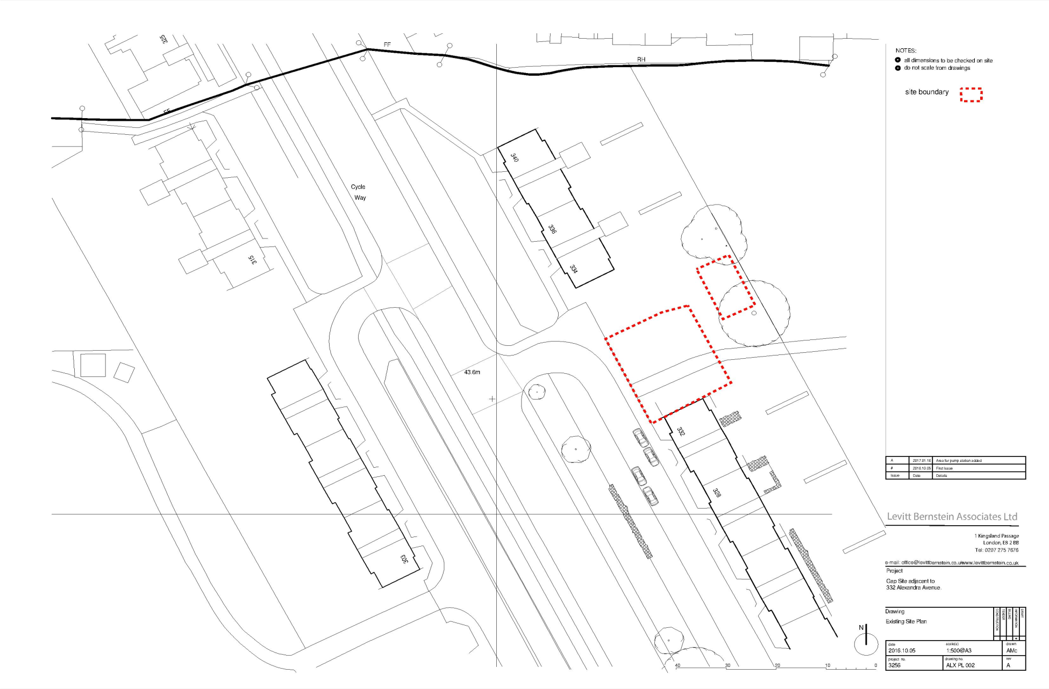

APPENDIX 3: PHOTOGRAPHS

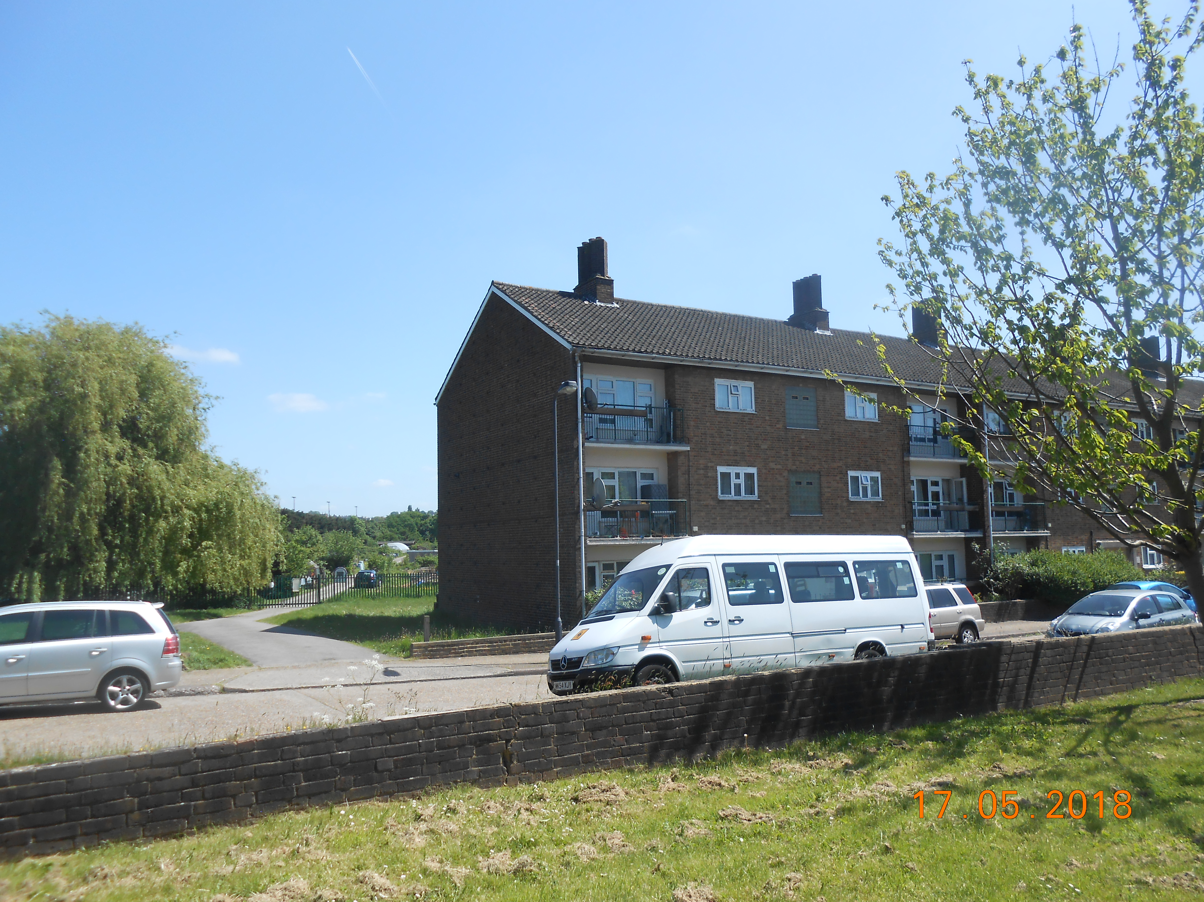

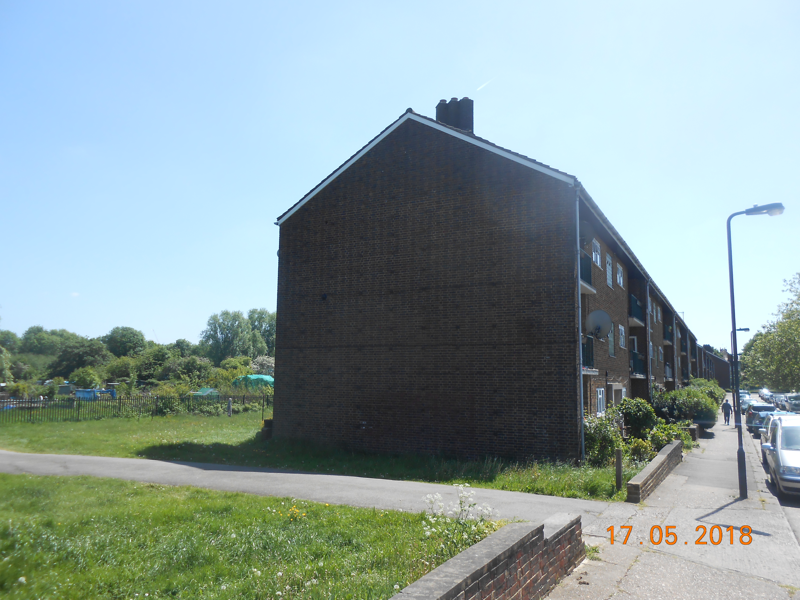

APPENDIX 4: PLANS AND ELEVATIONS

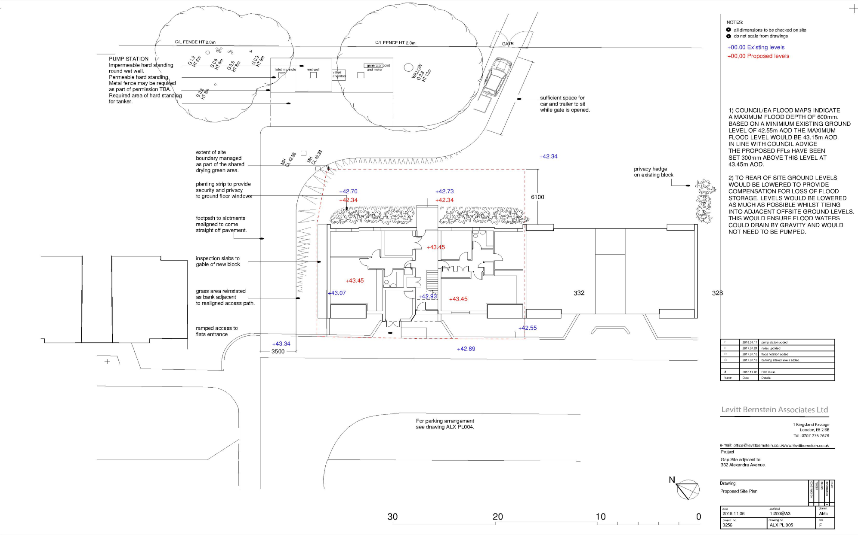

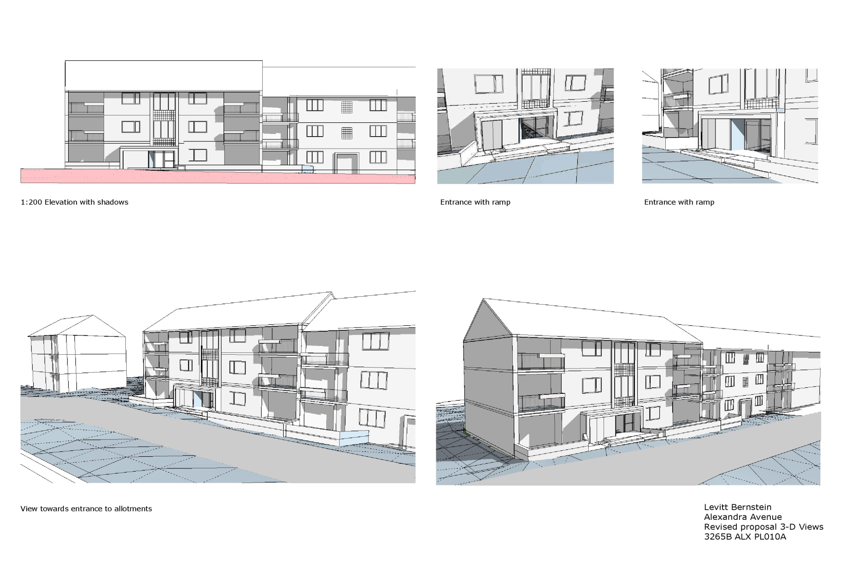
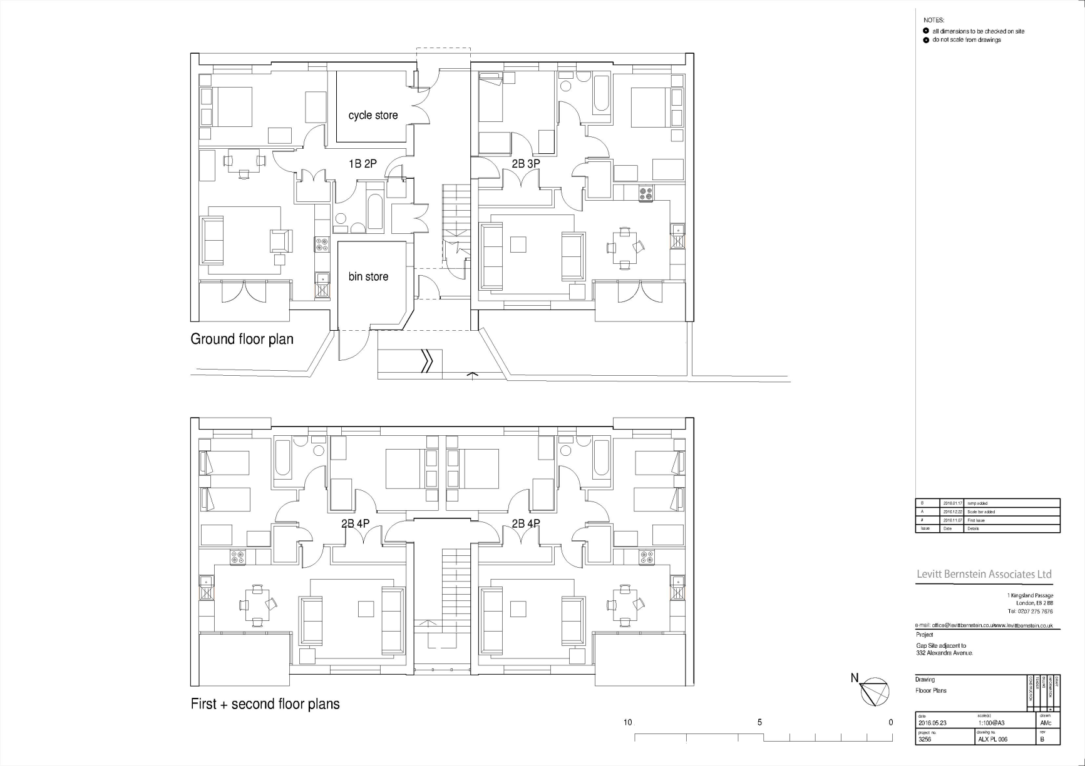
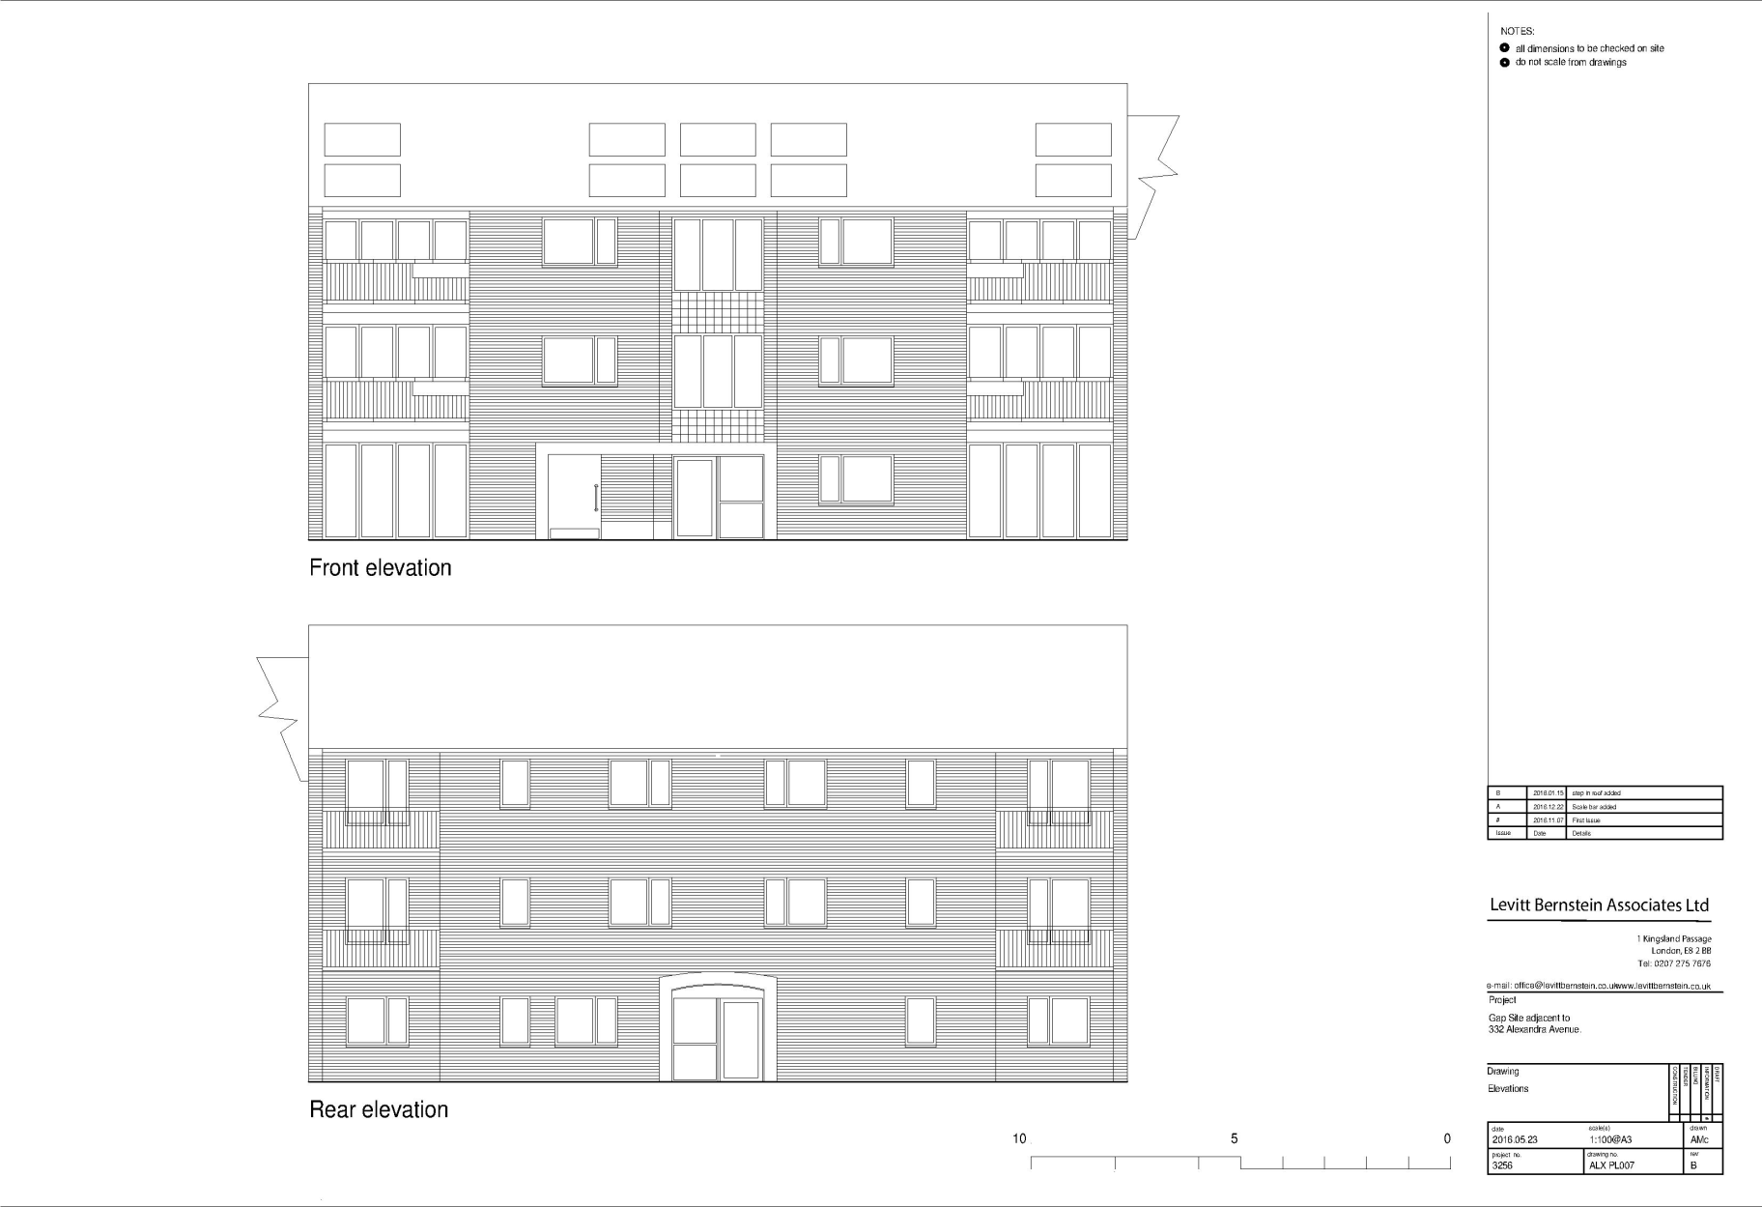
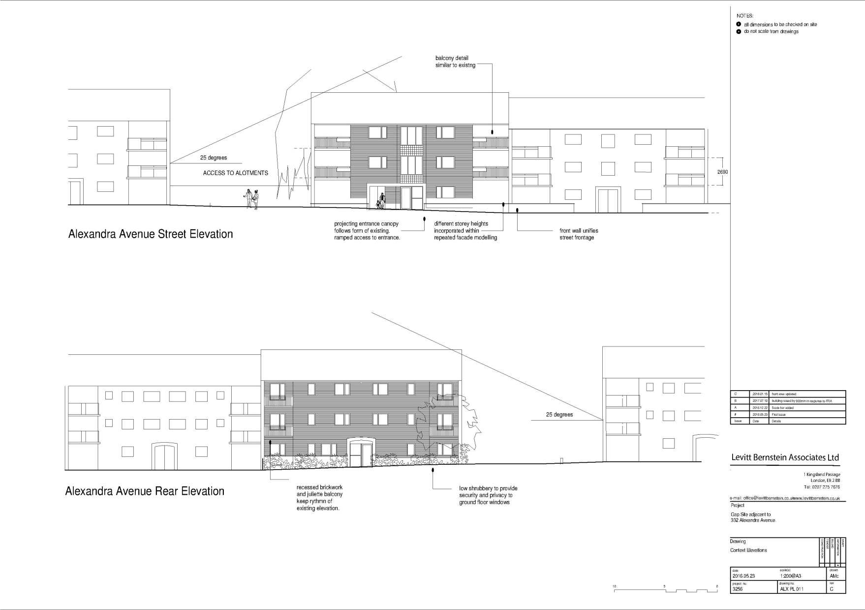

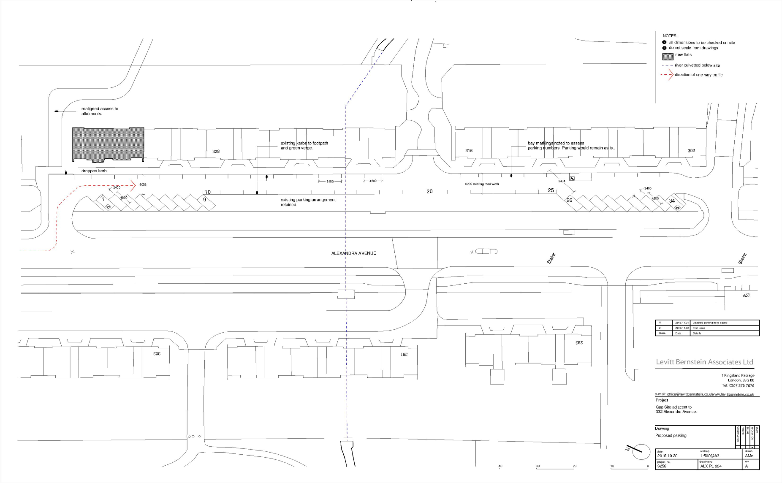

This page has been left intentionally blank

